Decision Tree- ATLS Parameters
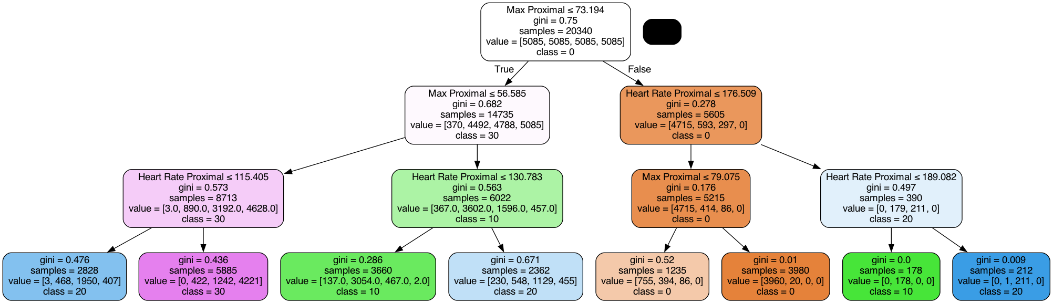

Decision Tree- 5 Parameters
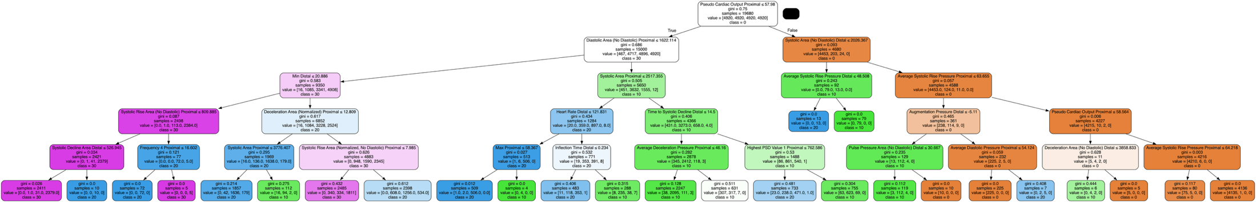

Random Forest without Genetic Algorithm- 5 Parameters
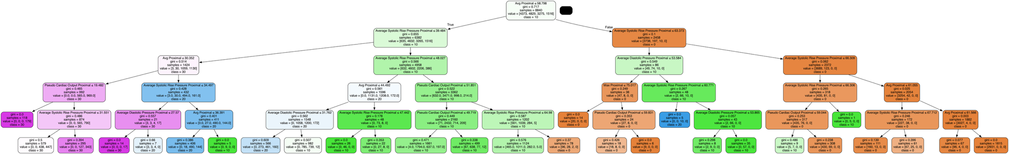

Random Forest with Genetic Algorithm- 5 Parameters